Top of Form

**Chapter 7**

Bottom of Form

Remember, changes to question templates won't automatically update quizzes that are already using those questions.

**Personal Reflection - Chapter 7 1 pts**

[*Edit this Question*](https://colostate.instructure.com/courses/94768/question_banks/170481) [*Delete this Question*](https://colostate.instructure.com/courses/94768/question_banks/170481)

This is a completely anonymous submission. The professor will be able to see the responses but the responses will not be attributed to an author. Your participation is required.

What do you think about the content of this chapter? Did you learn anything new? Do you need to do some more practice? What do you think about the other chart types (that I said were garbage)? Do you agree / disagree? Do some personal reflection.

[move/copy question to another bank](https://colostate.instructure.com/courses/94768/question_banks/170481)

**Question 7.1: What is the path? 1 pts**

[*Edit this Question*](https://colostate.instructure.com/courses/94768/question_banks/170481) [*Delete this Question*](https://colostate.instructure.com/courses/94768/question_banks/170481)

Look at the MATLAB screenshot taken on a Windows computer. What is the user’s current path (also called the current working directory) based off this image?

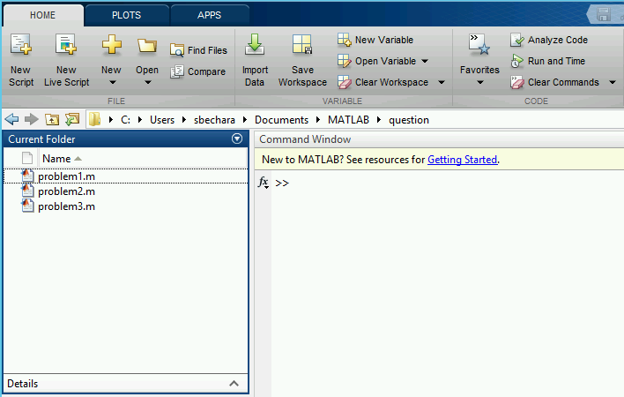

**Correct Answer** A. C:\Users\sbechara\Documents\MATLAB\question

B. C:\Users\sbechara\Documents\MATLAB\question\problem1.m

C. C:\Users\sbechara\Documents\MATLAB\

D. C:/Users/sbechara/Documents/MATLAB/question

E. C:/Users/sbechara/Documents/MATLAB/

[move/copy question to another bank](https://colostate.instructure.com/courses/94768/question_banks/170481)

**Question 7.2: Mathematical operators in MATLAB 1 pts**

[*Edit this Question*](https://colostate.instructure.com/courses/94768/question_banks/170481) [*Delete this Question*](https://colostate.instructure.com/courses/94768/question_banks/170481)

Match the description of the mathematical operation with the MATLAB command.

* Four plus five - 4+5
* Three to the power of six - 3^6
* Fifteen divided by three squared - 15/3^2
* Six minus seven times eight - 6-7*8

[move/copy question to another bank](https://colostate.instructure.com/courses/94768/question_banks/170481)

**Question 7.3: Order of Precedence with Arithmetic 1 pts**

[*Edit this Question*](https://colostate.instructure.com/courses/94768/question_banks/170481) [*Delete this Question*](https://colostate.instructure.com/courses/94768/question_banks/170481)

Consider MATLAB evaluating the expression (4*4^2/2)+(3-34*2). Based off of the MATLAB order of precedence, what should the resultant be?

**Correct Answer** -33

[move/copy question to another bank](https://colostate.instructure.com/courses/94768/question_banks/170481)

**Question 7.4: Variable Naming 1 pts**

[*Edit this Question*](https://colostate.instructure.com/courses/94768/question_banks/170481) [*Delete this Question*](https://colostate.instructure.com/courses/94768/question_banks/170481)

Is the following variable name valid or invalid?

1. >> x7

2. >> x_7

3. >> n_factorial

**Correct Answer** all valid

[move/copy question to another bank](https://colostate.instructure.com/courses/94768/question_banks/170481)

**Request for Feedback - Chapter 7 1 pts**

[*Edit this Question*](https://colostate.instructure.com/courses/94768/question_banks/170481) [*Delete this Question*](https://colostate.instructure.com/courses/94768/question_banks/170481)

This is a completely anonymous submission. The professor will be able to see the responses but the responses will not be attributed to an author. Your participation is required.

What did you think of this chapter? Anything stand out as exceptionally good? Anything that you would like to see differently? Any feedback is appreciated.

[move/copy question to another bank](https://colostate.instructure.com/courses/94768/question_banks/170481)

Top of Form